Directions to Hofstra University from the Hampton Inn

From Hampton Inn (A) to Hagedorn Hall (B)  for Miscue Conference, July 15-17:  South on E. Gate Blvd. (Right turn from North Ave.)  Turn right on Zeckondorf Blvd  Take Meadowbrook Pkwy south  Exit Hempstead Tpke Rte 24 (exit # M4)  2nd exit on long off ramp feeds onto Hempstead Tpke.  2nd light, left turn at Uniondale Ave. (McDonalds)  Take first driveway on right into Hagedorn Hall | From Hampton Inn (A) to Student Center (C)  for WLU/Literacies for All Conference, July 18-20:  South on E. Gate Blvd. (Right turn from North Ave.)  Turn right on Zeckondorf Blvd  Take Meadowbrook Pkwy south  Exit Hempstead Tpke Rte 24 (exit # M4)  2nd exit on long off ramp feeds onto Hempstead Tpke.  3rd light, right turn into Hofstra. Left turn at 2nd Stop sign. Student Center is on left, parking is on right.

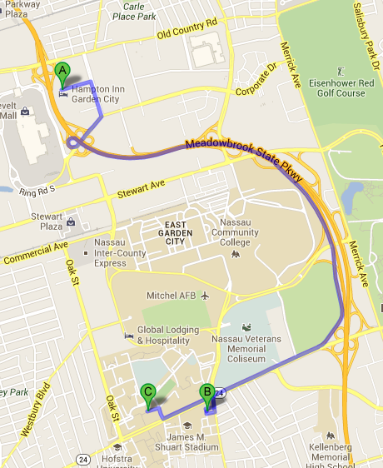
Or use this link:
http://goo.gl/maps/uxO3A
Lost? Call for directions: Debi 516-850-5024; Alan: 631-796-3211

